SKILL PROGRAMS
ARNAV CHITIKENA 2520030331
SKILL 1 Shell Initialization and Welcome Banner
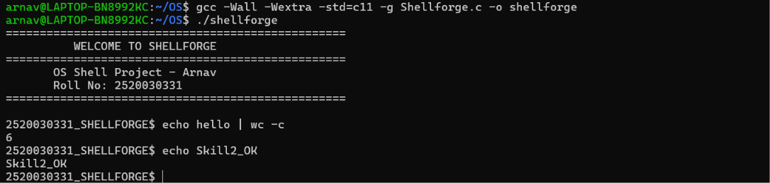
SKILL 2 Basic Shell Loop and Command Prompt
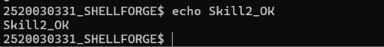

SKILL 3 Command Parsing and Tokenization
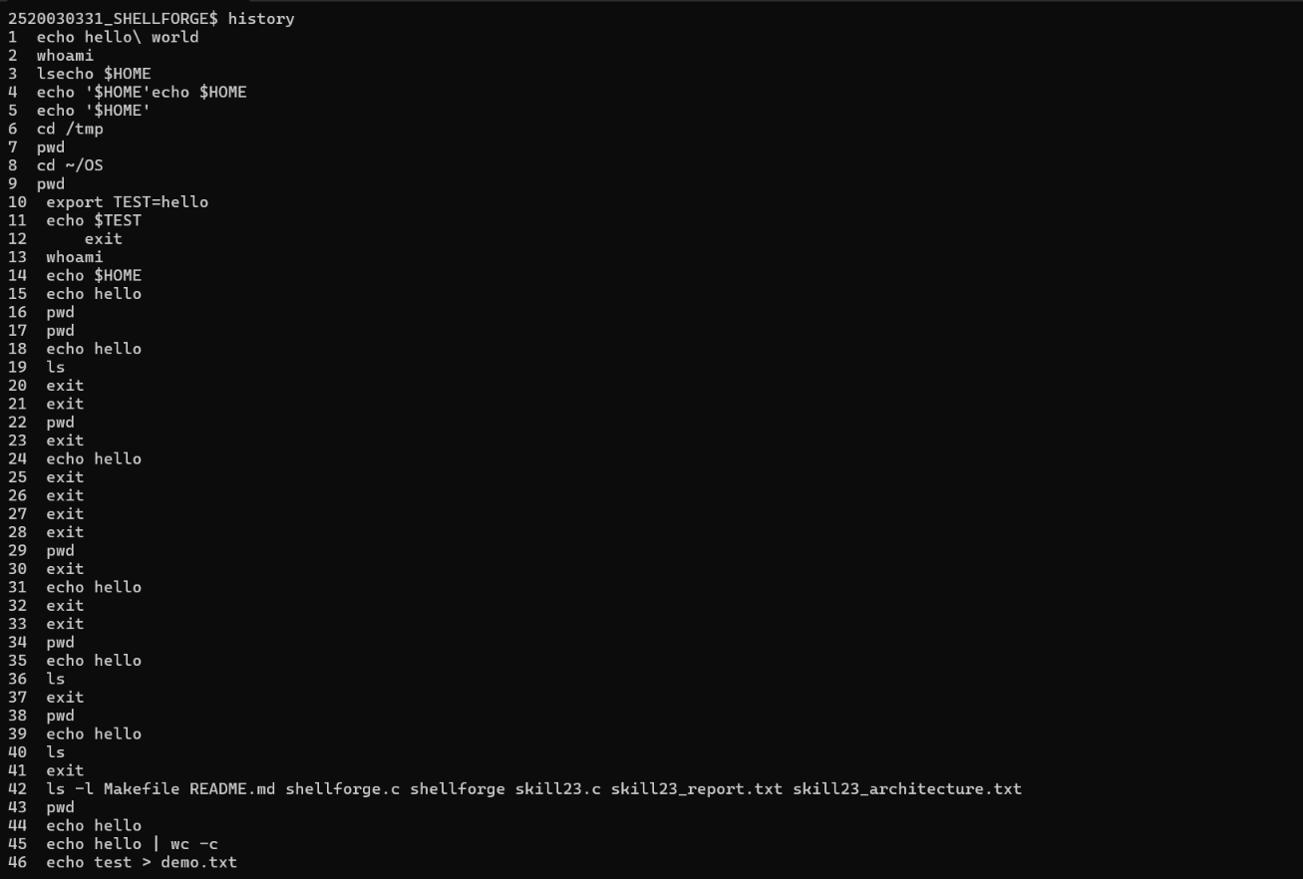
SKILL 4 Command History Management
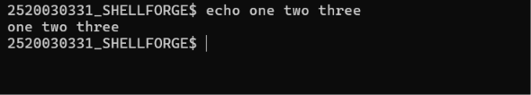
SKILL 5 Built-in Commands Implementation

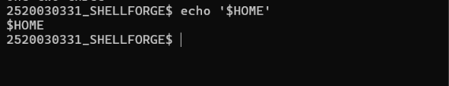

SKILL 6 Environment Variable Expansion
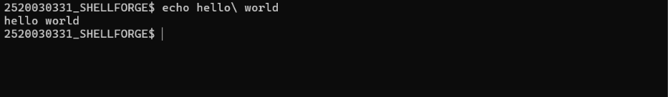

SKILL 7 Quoting and Escape Character Handling
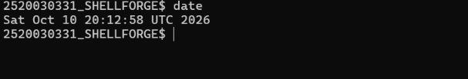

SKILL 8 External Command Execution
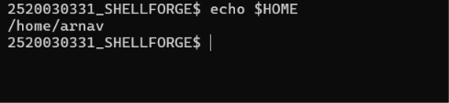

SKILL 9 PATH Resolution and Command Execution
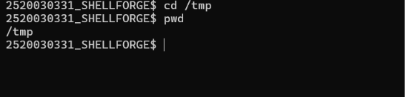

SKILL 10 Shell Exit and Cleanup
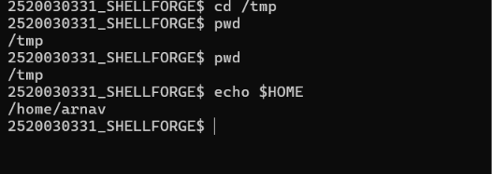

SKILL 11 Command Execution and Error Handling

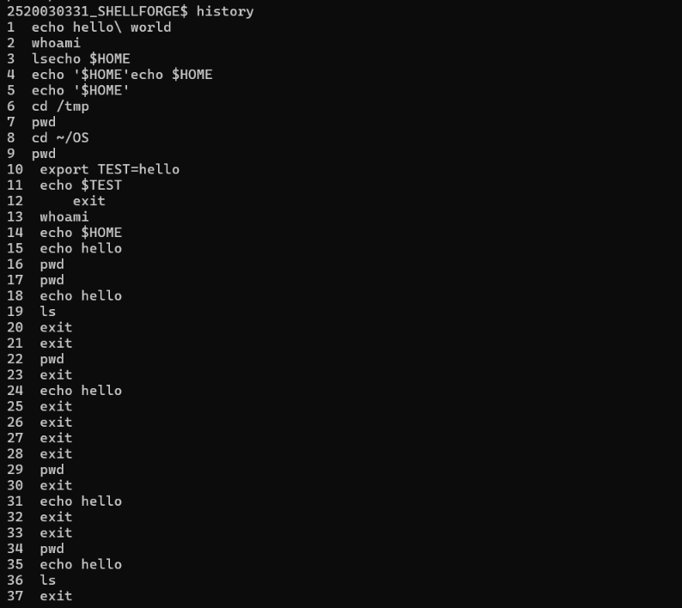

SKILL 12 Pipeline Implementation

SKILL 13 Input and Output Redirection
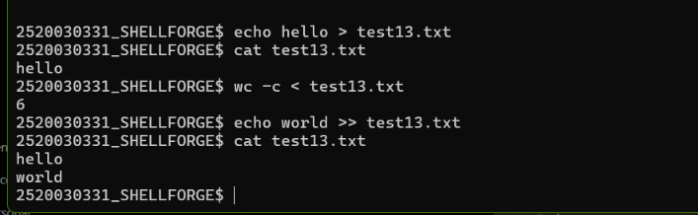

SKILL 14 Error Stream Redirection
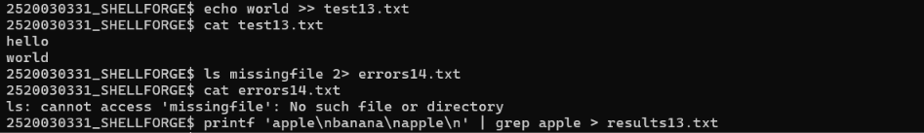

SKILL 15 Combined Pipeline and Redirection
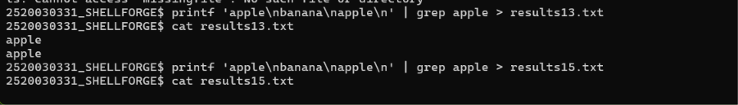

SKILL 16 Background Process Execution and Job Management
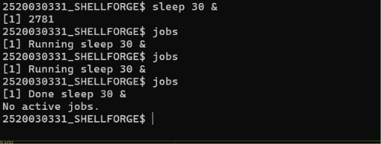

SKILLL 17 Signal Handling and Ctrl+C Interruption
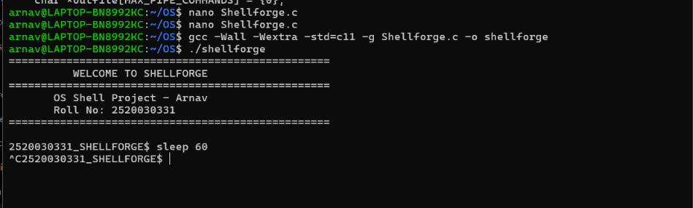

SKILL 18 Foreground and Background Job Control
Foreground
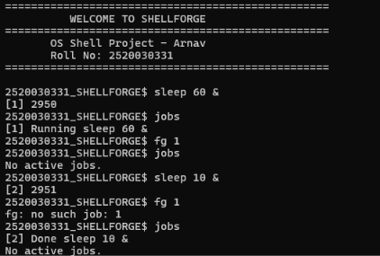
Background

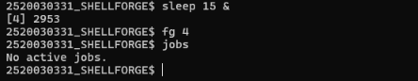

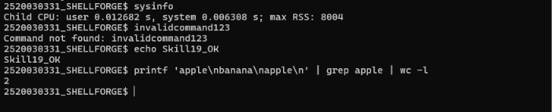
SKILL 19 System Resource Usage Monitoring

SKILL 20 Built-in Help and Background Job Completion

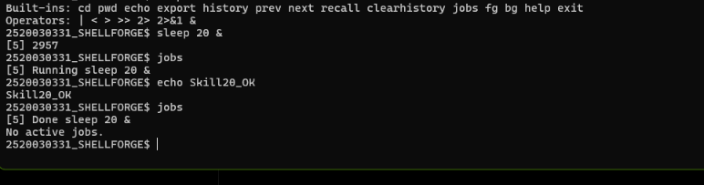

SKILL 21 Error Handling and Shell Integration
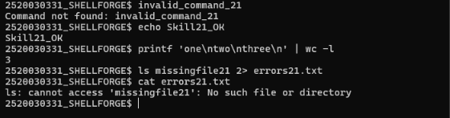

SKILL 22 Automated Testing and Memory Validation
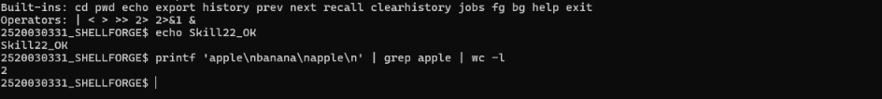

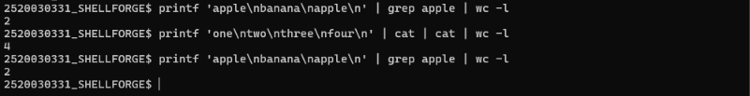
SKILL23 Pipeline Stress Testing and Resource Monitoring

SKILL 24 Project Integration, Build, Documentation, and Release Validation
